Task on Load balancers
1.Configure Classic Load balancer.
Go to AWS Console → Load BalancersClick Create Load Balancer.
Choose Classic Load Balancer
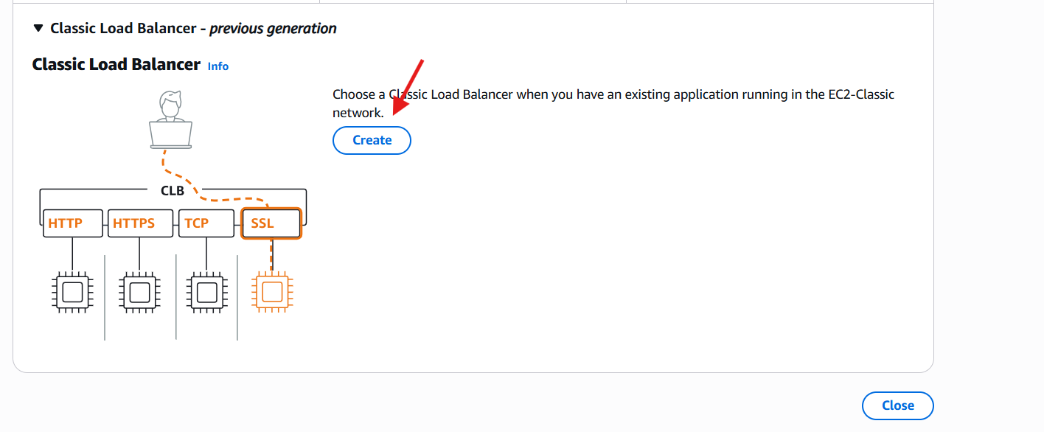
Create load balancername and select scheme and also select vpc and subnets.
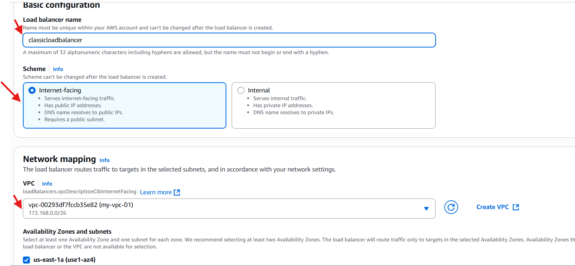
Confirm the protocols and enable listners and routing.
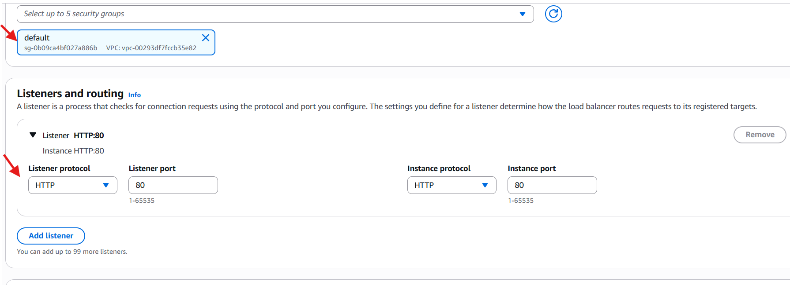
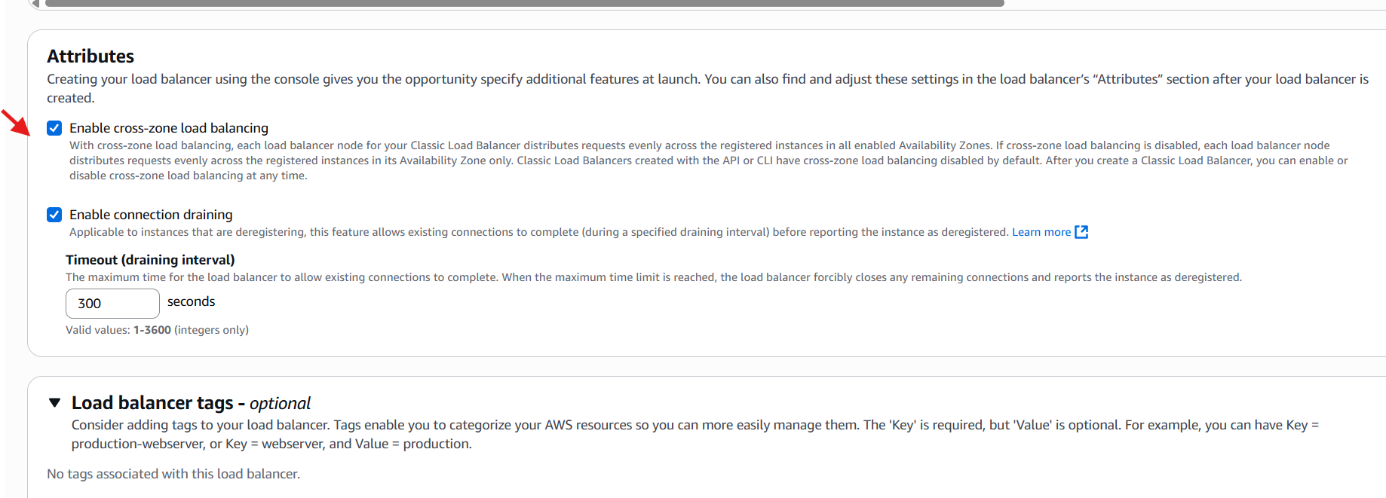
we can see the configurations in summary. if it is ok click on create load balancer.
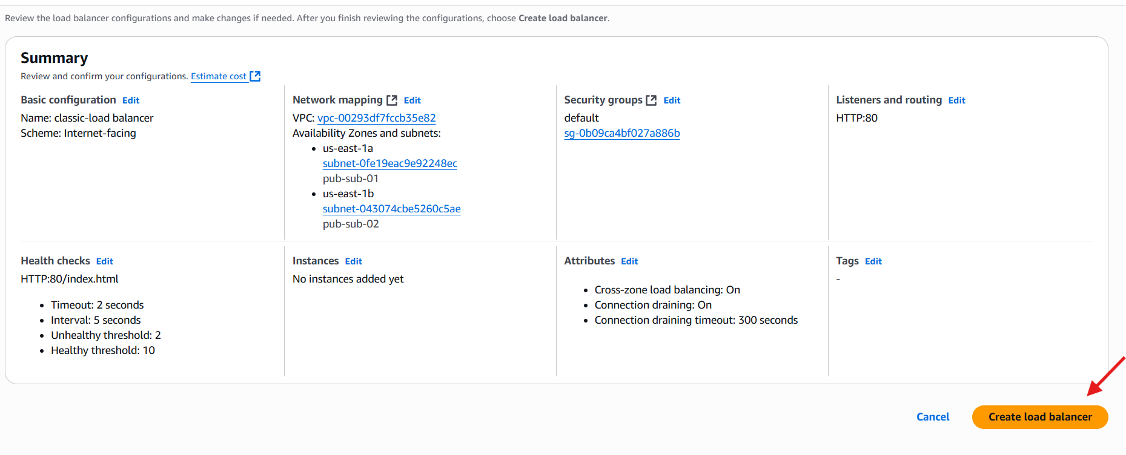
Here, are the results.
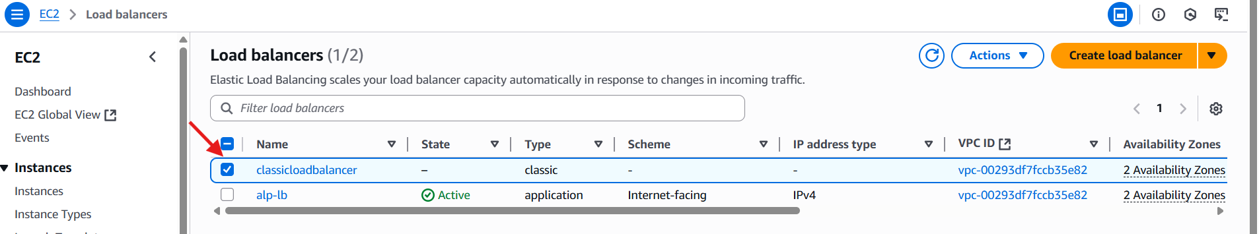
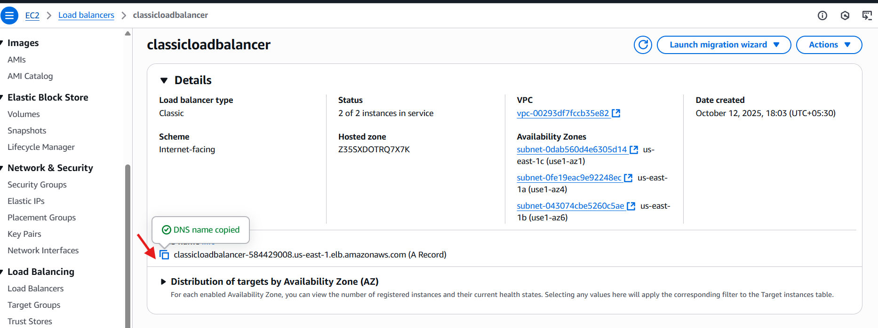
Copy the dns name:80 and go to browser and check.
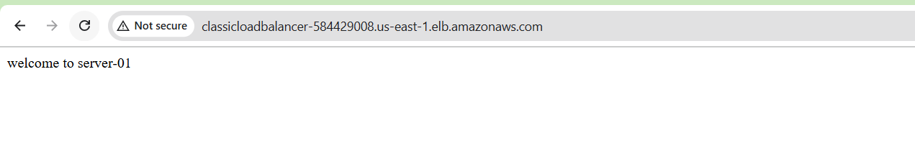
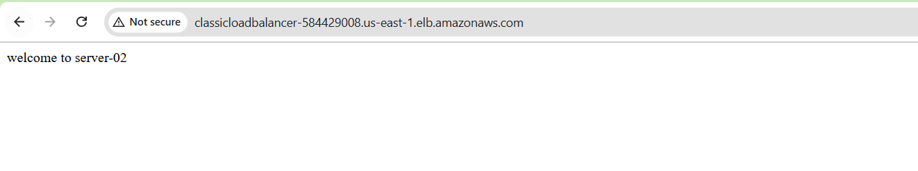2.Configure Application Load balancer.
Go to EC2 → Load Balancers → Create Load Balancer.
Choose Application Load Balancer.
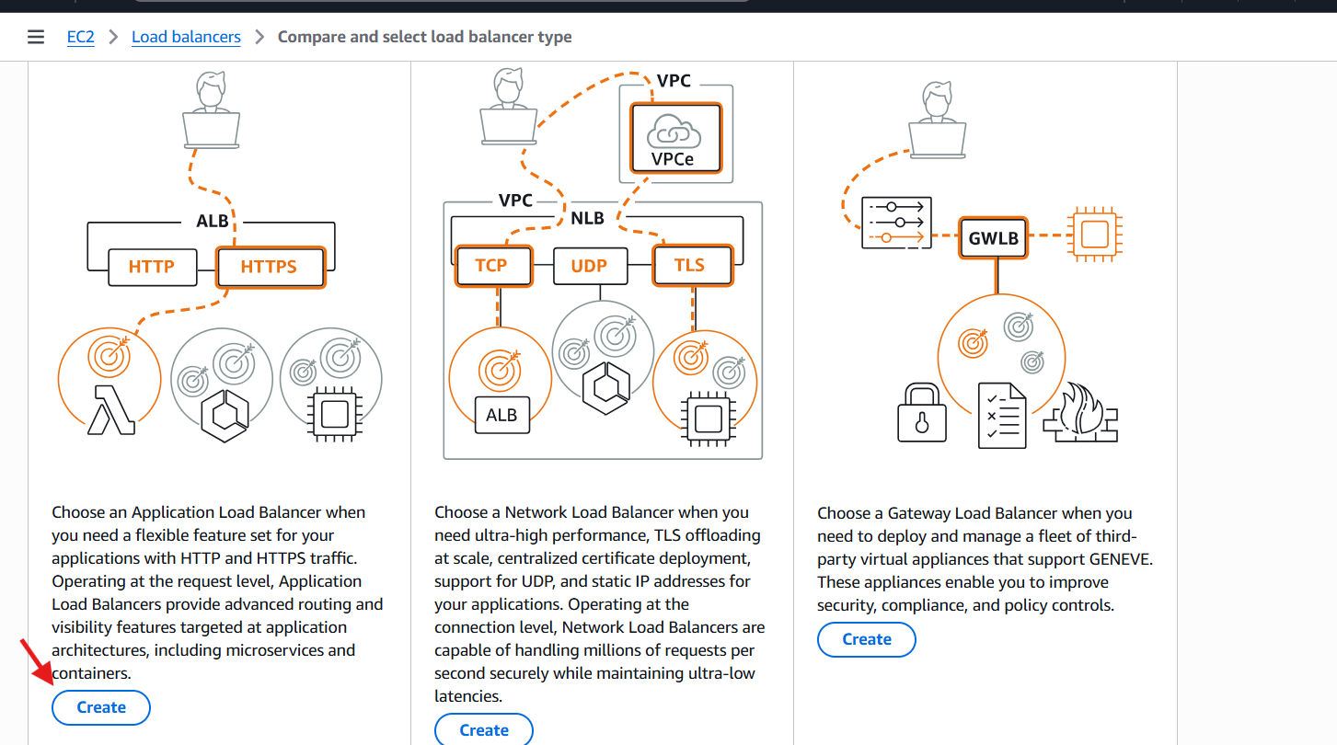
We give the load balancer name and select the scheme .
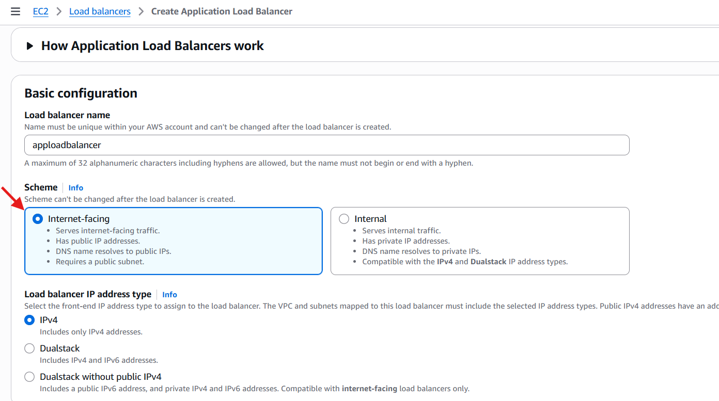
Select the vpc and availability zones.
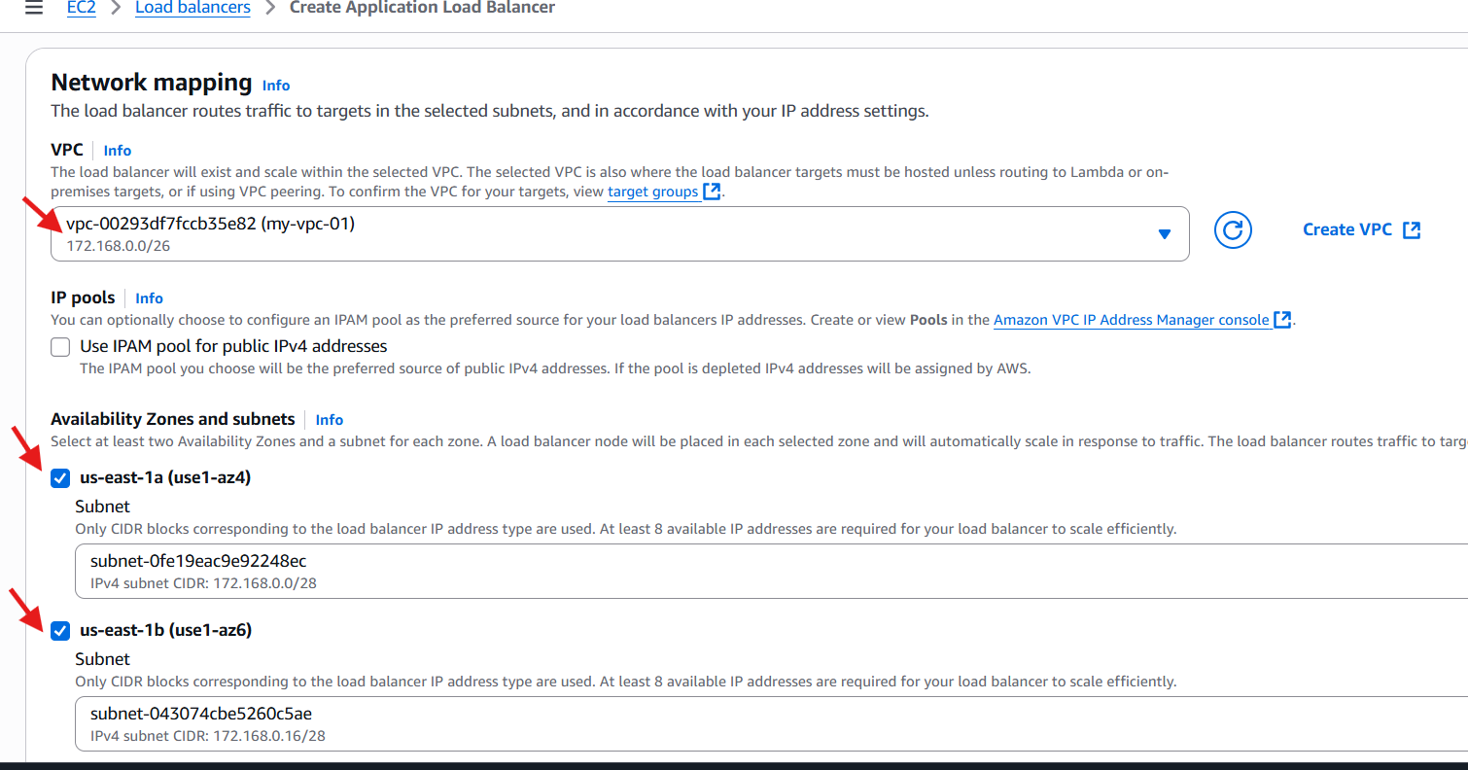
In APL we create the target groups.
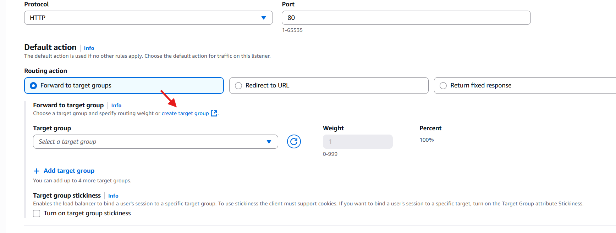
Go to ec2select target groupschoose instance type.
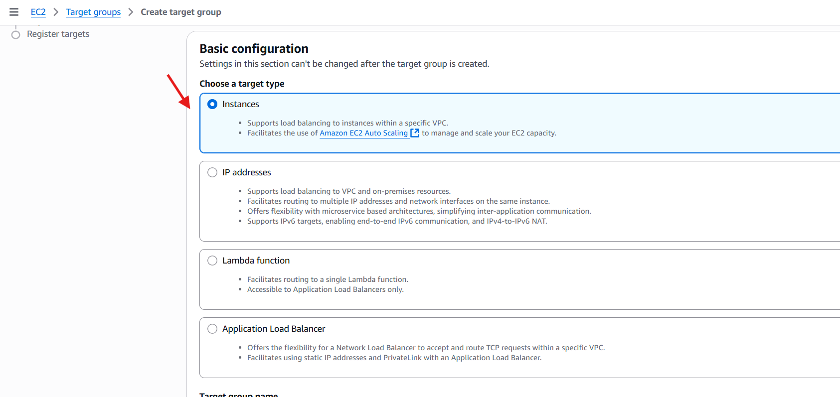
Give the target name and select the vpc and also configure the health check path.
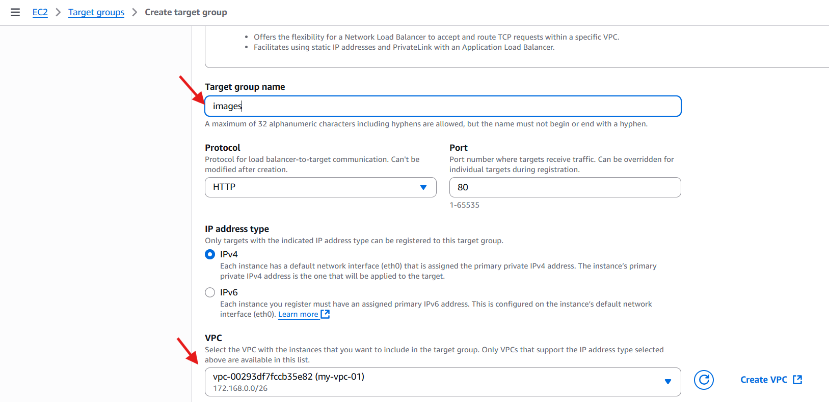
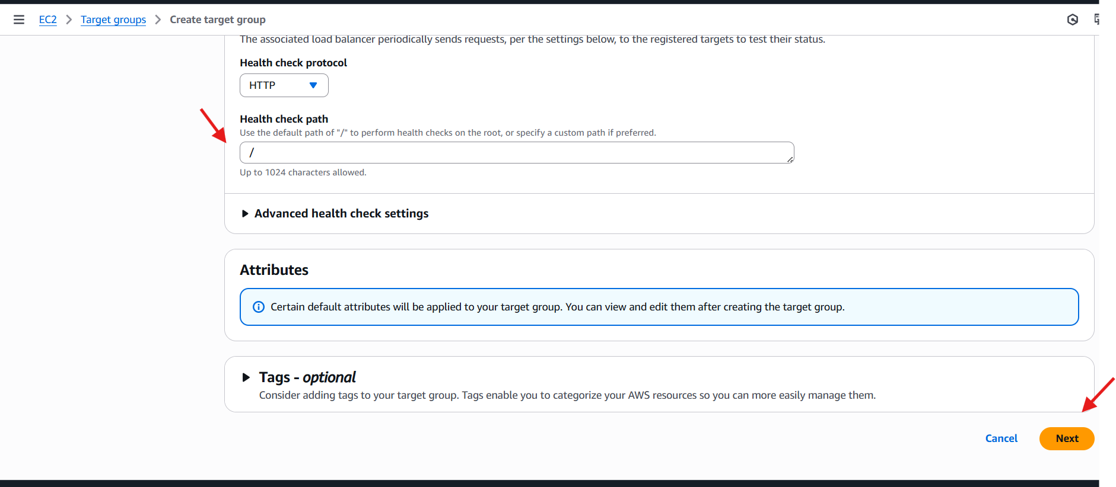
Target group is created.
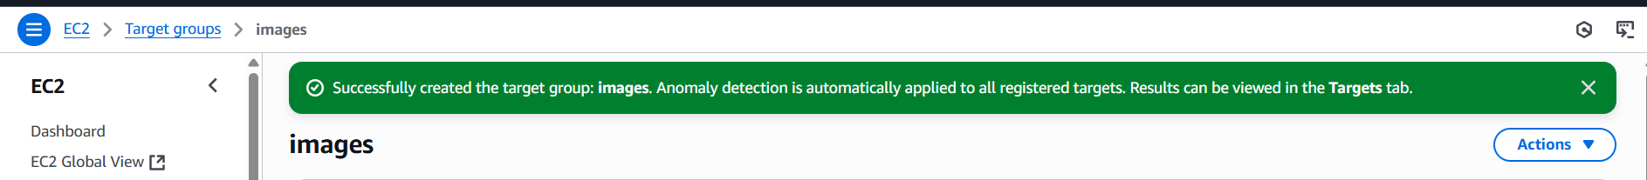
Go to ec2 andselect the target group and create a load balancer.
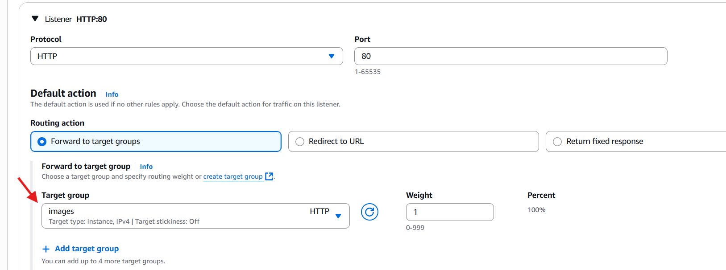
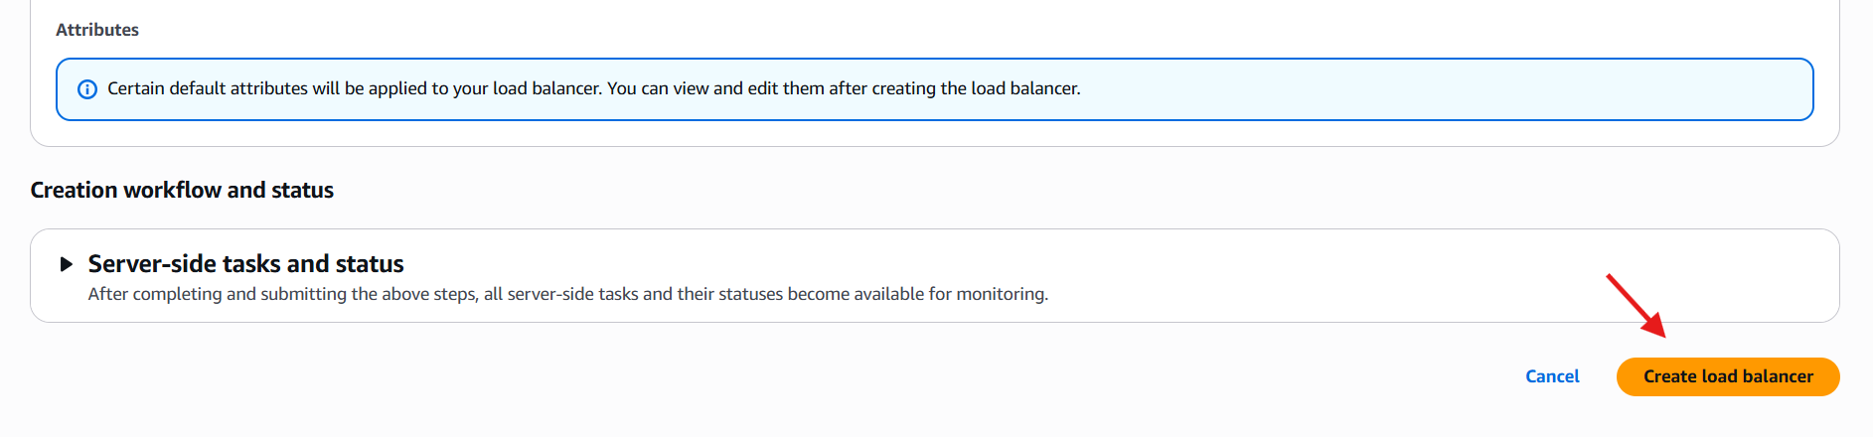
Go to target groups and register the targets and also check the health status.
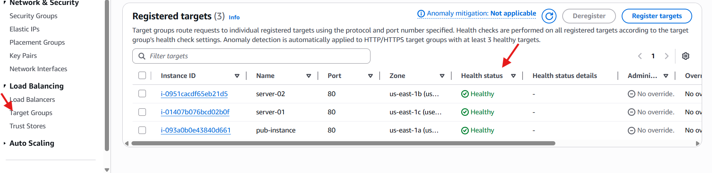
We can check in browser.
Dns name:80

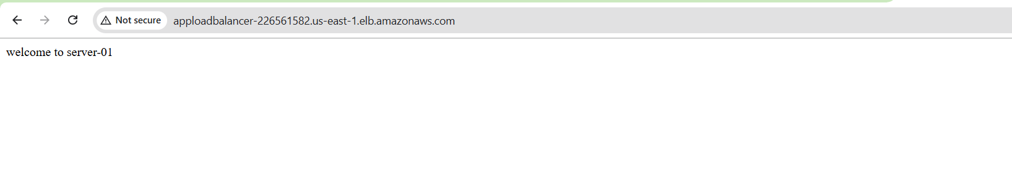
In the instance level we can configure the path.
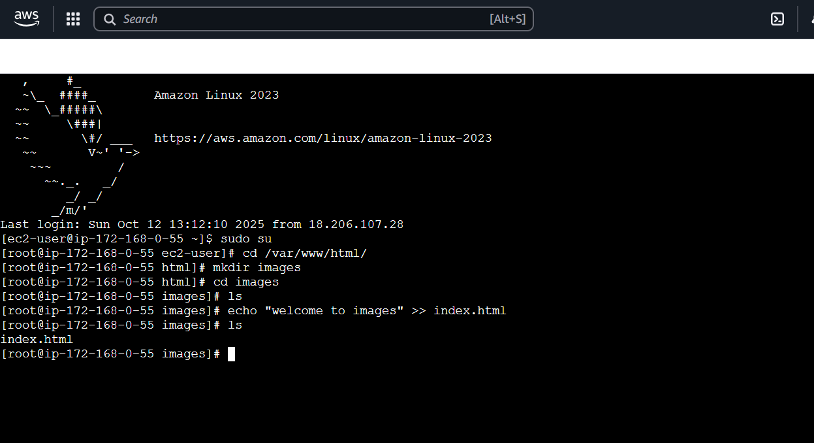
Path/images.
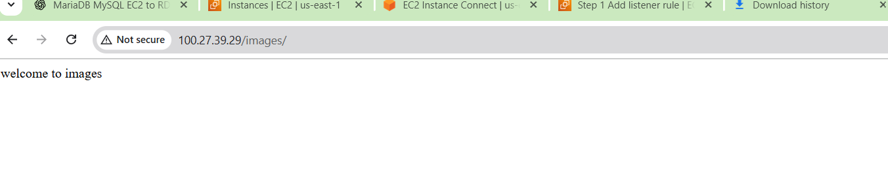
Go to load balancer and create a rule and give the path.
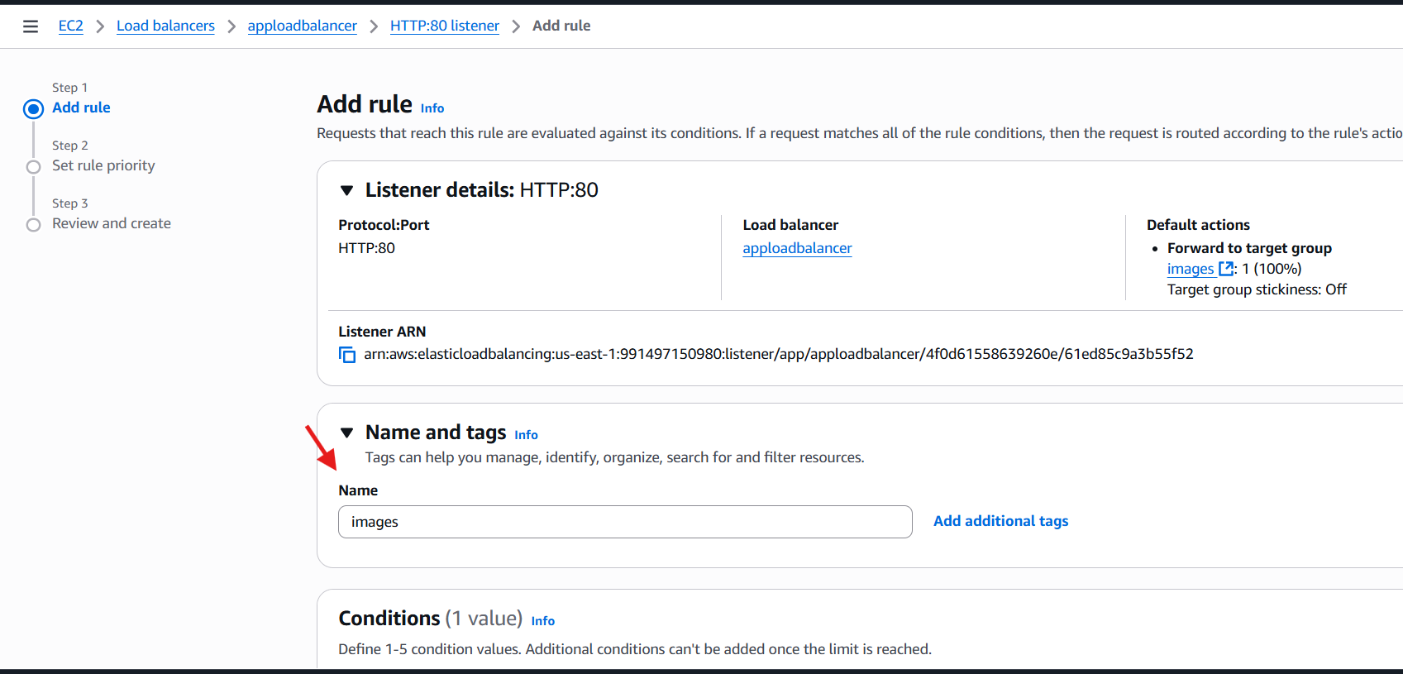
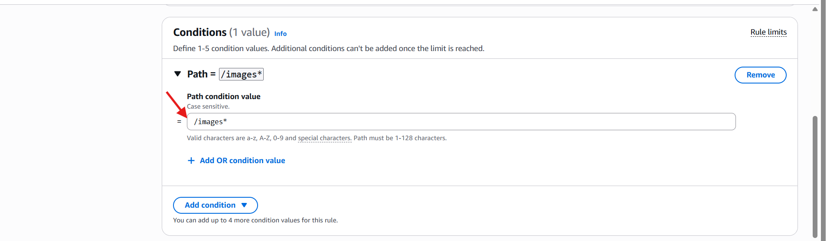
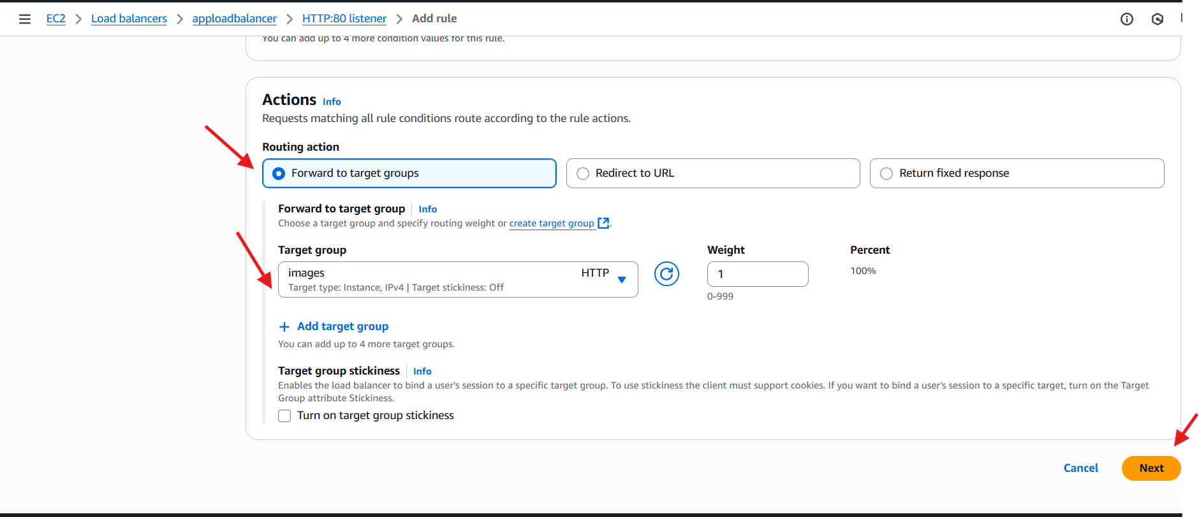
And also set the priority and click next.
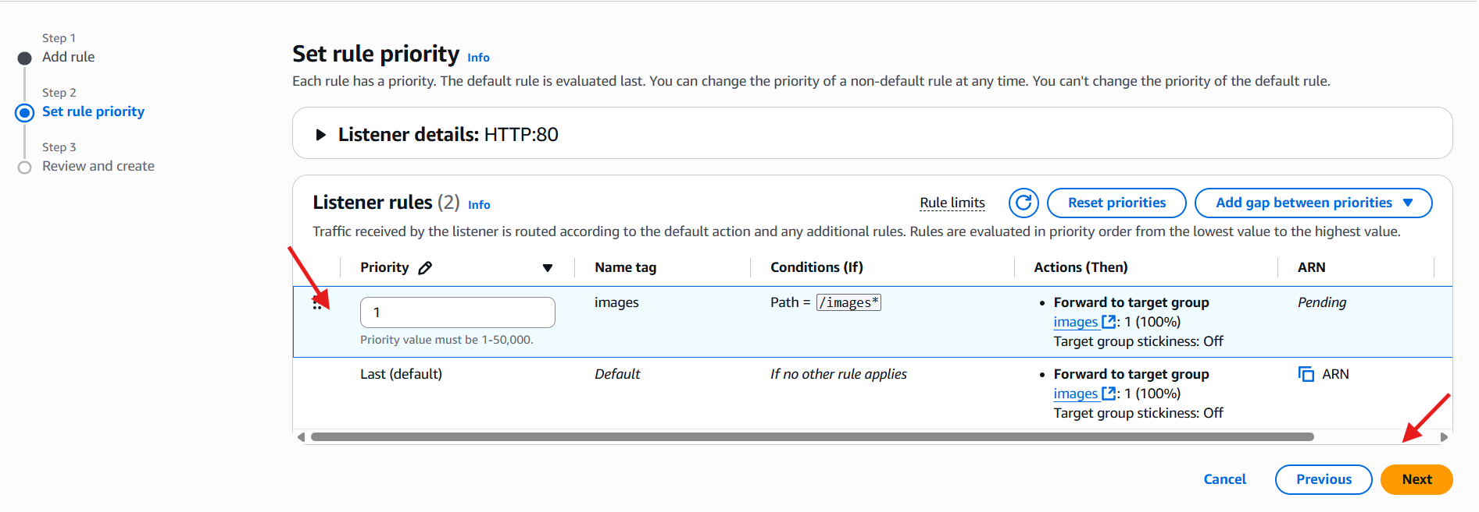
Dnsname/80.
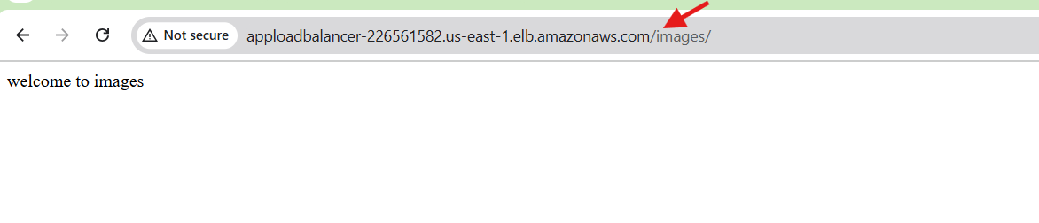

3.Configure Network Load balancer.
Go to EC2 → Load Balancers → Create Load Balancer.
Choose network Load Balancer
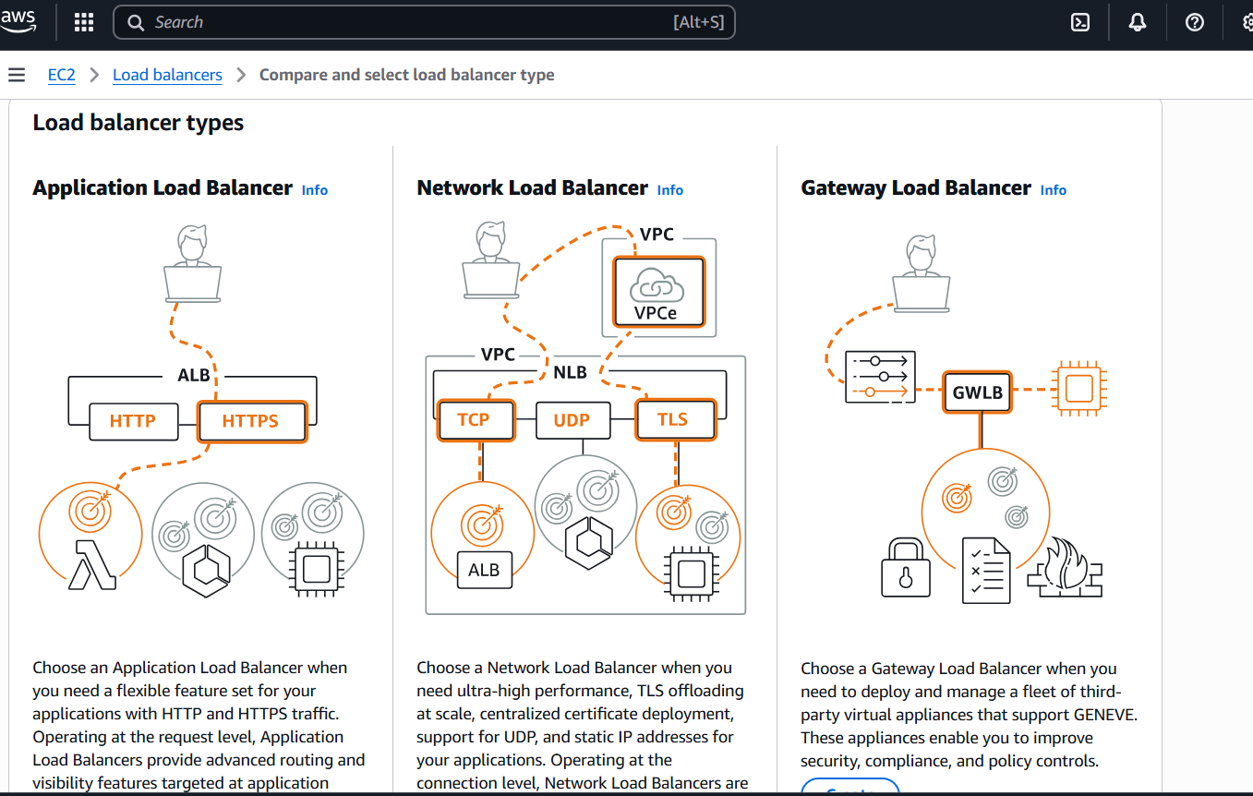
Same like application load balancer we create target group.
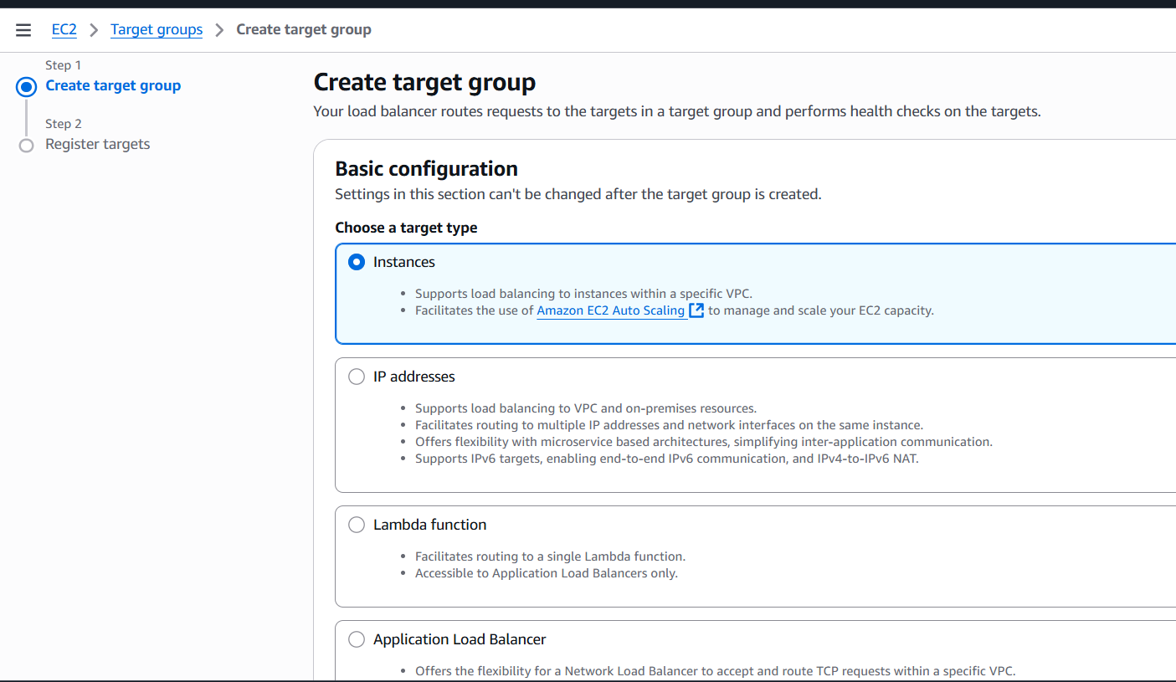
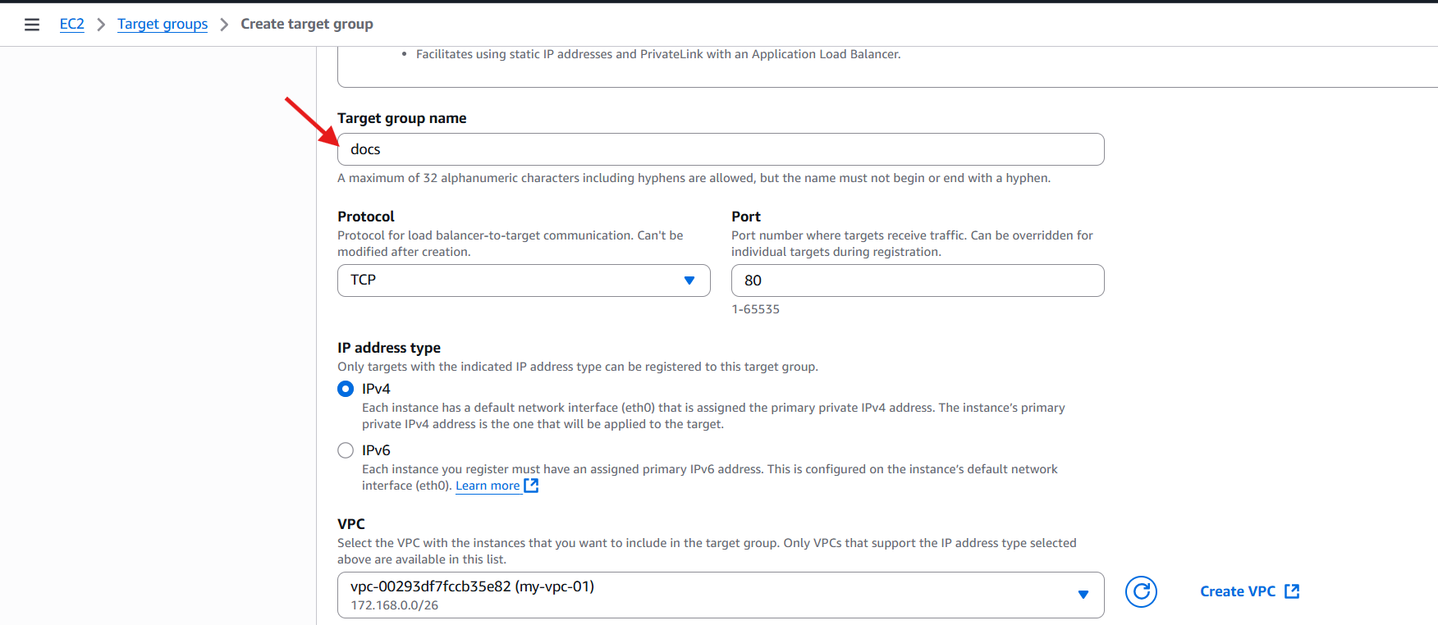
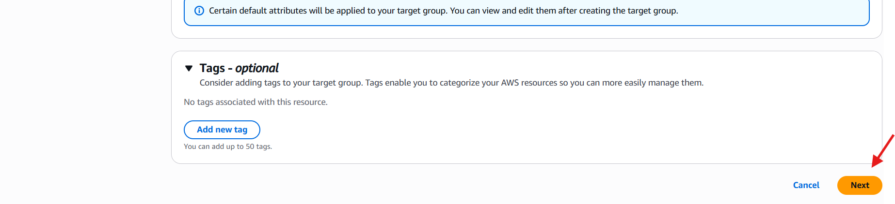
And also register the targets.
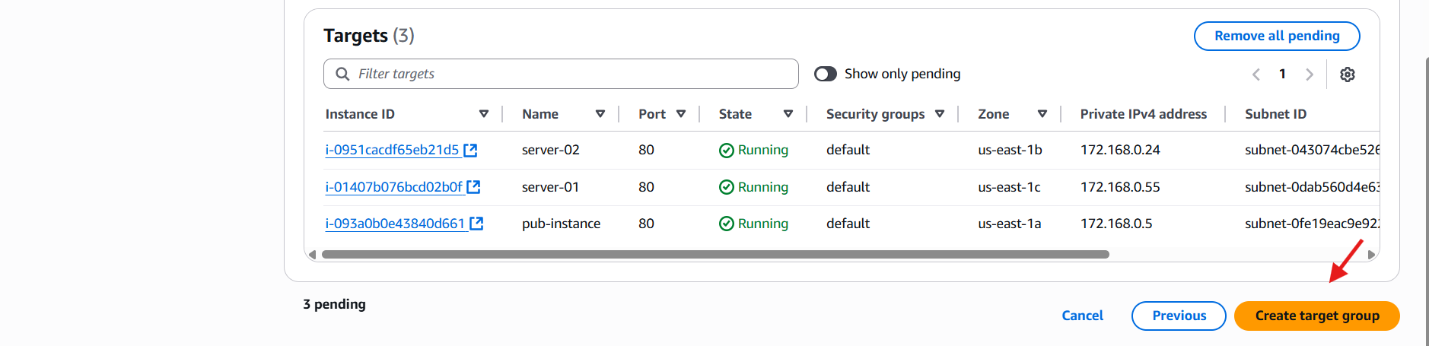
Then go to load balancersselect scheme and configure the listners.
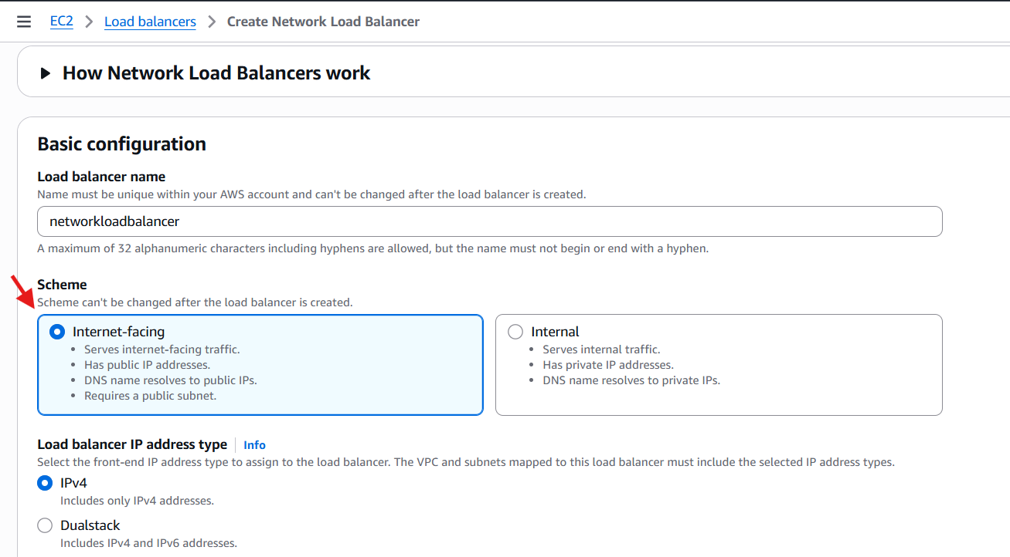
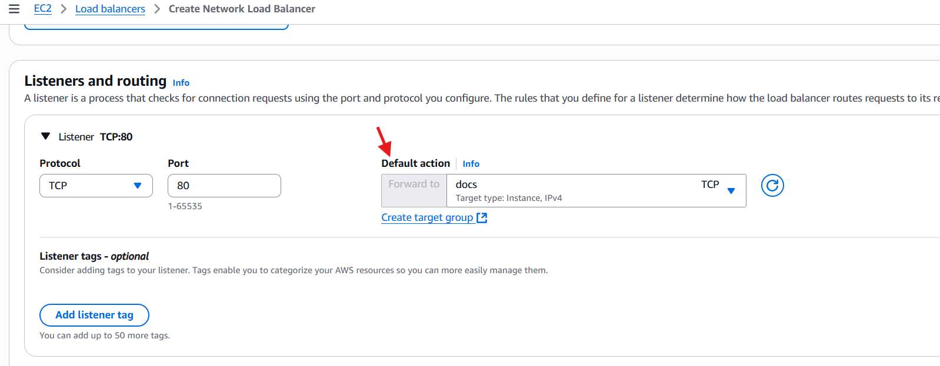
We can check the configurations in the summary and it is ok we can click on create load balancer.
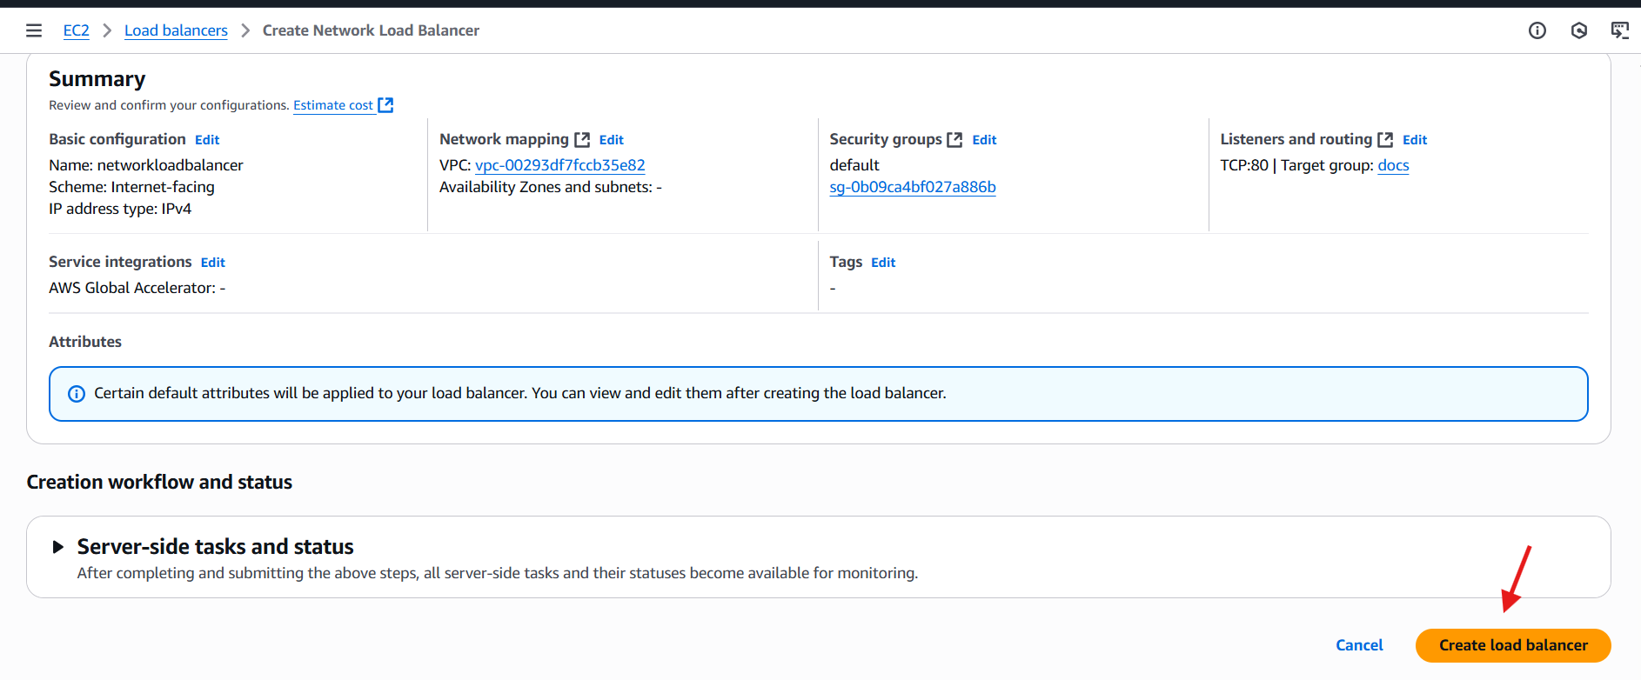
Once it is active we can check in the browser.
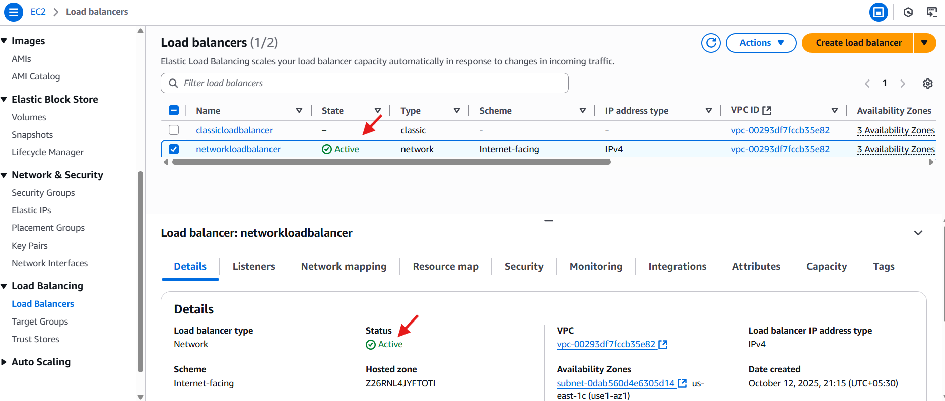


4.Attach SSL for application load balancer.
Go to load balancers and click on add listners we can give the protocol number and select the target groups.
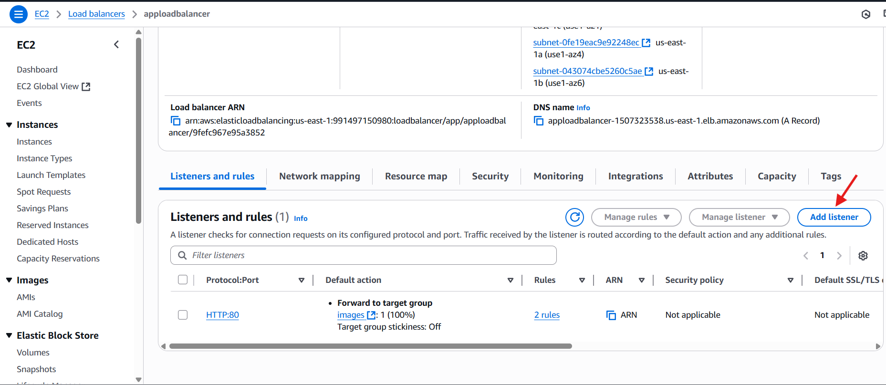
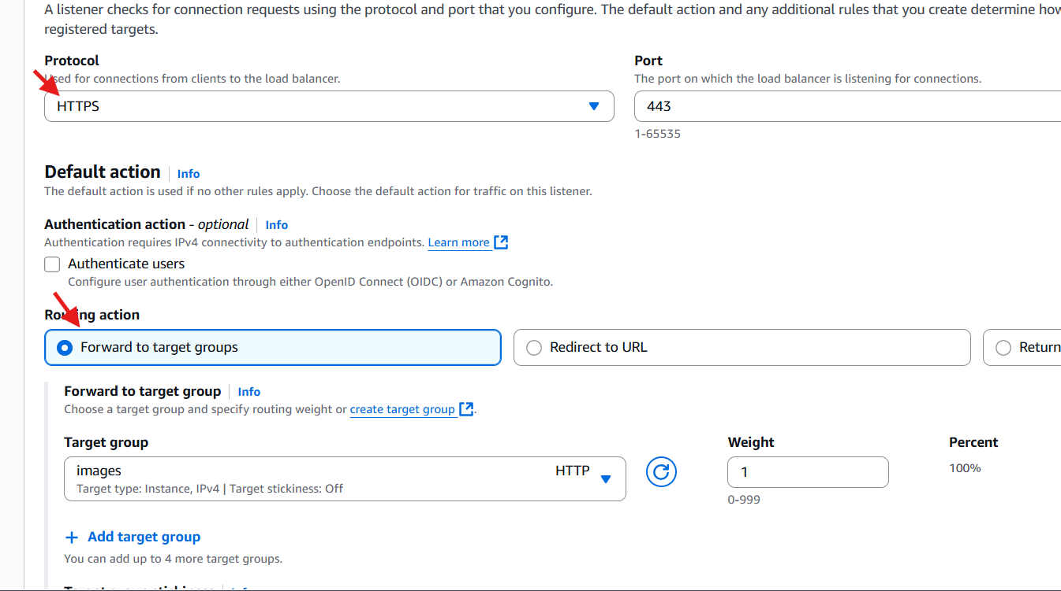
And also we can select the certificate and add.
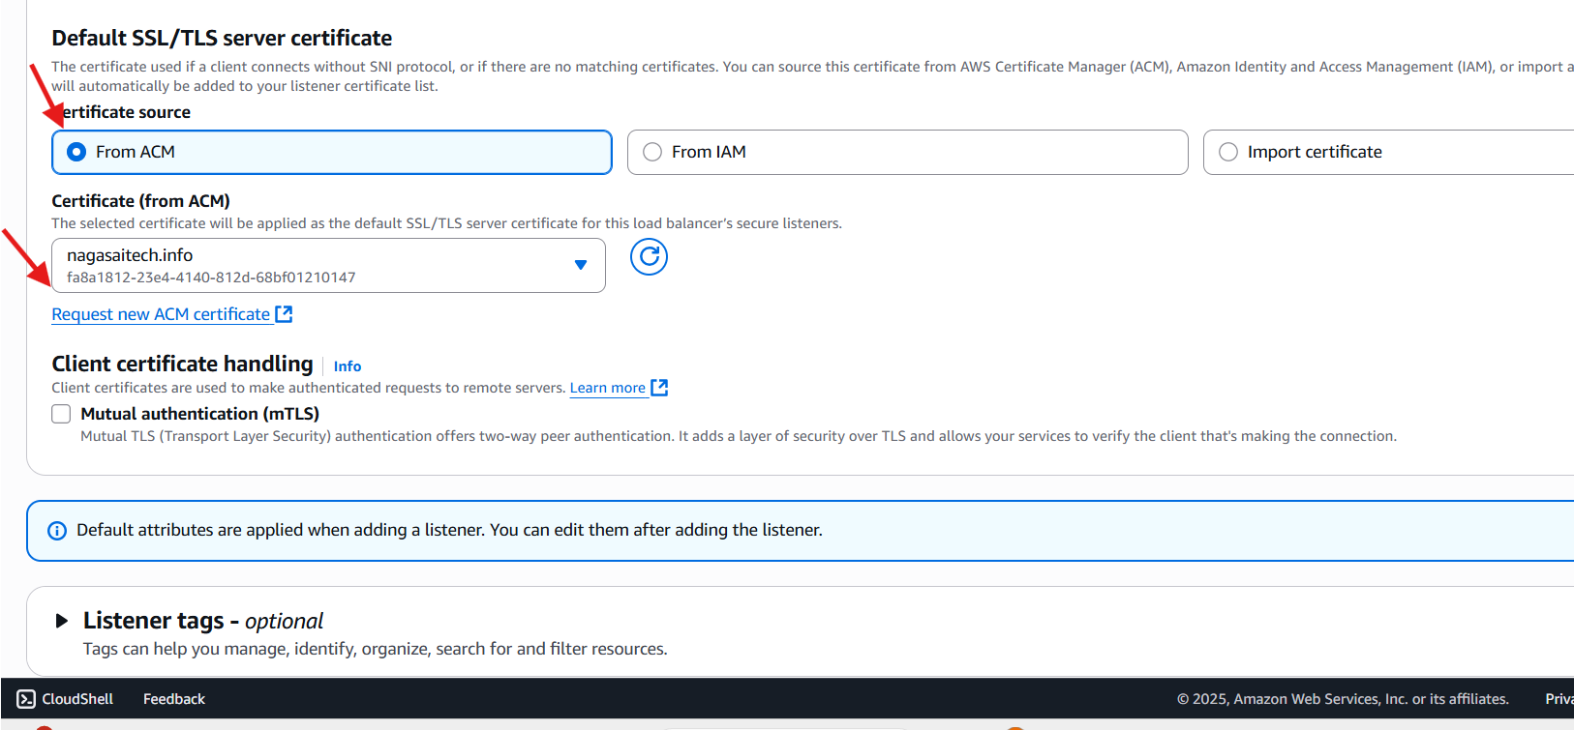

5.Map Application load balancer to R53.
For this task go to r53hosted zonesselect the bucket and click on create record and select the record type and alias and click on create records.
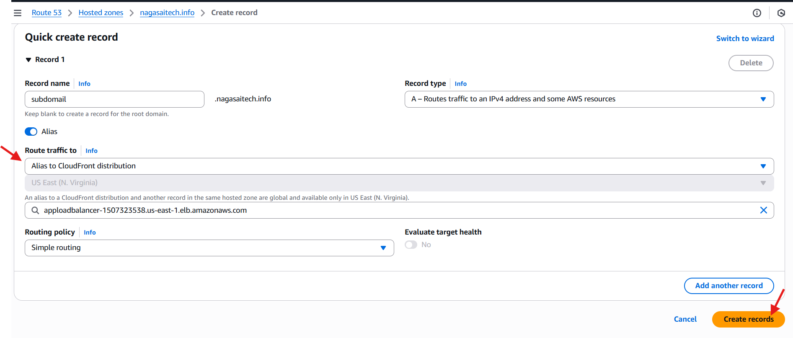
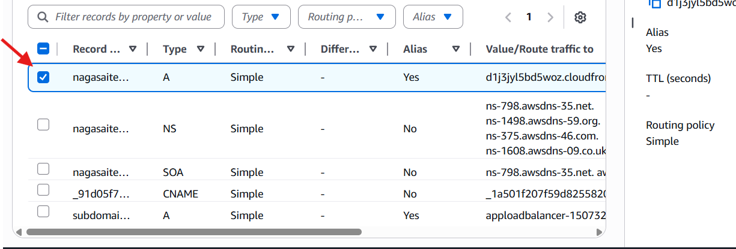
6.Push the application load balancer logs to s3.
Go to the bucket and create a policy.
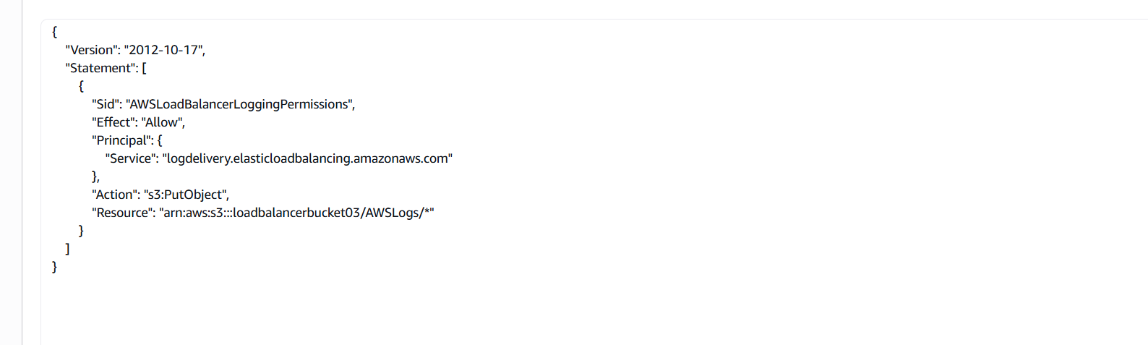
Go to load balancerselect attributesedit .
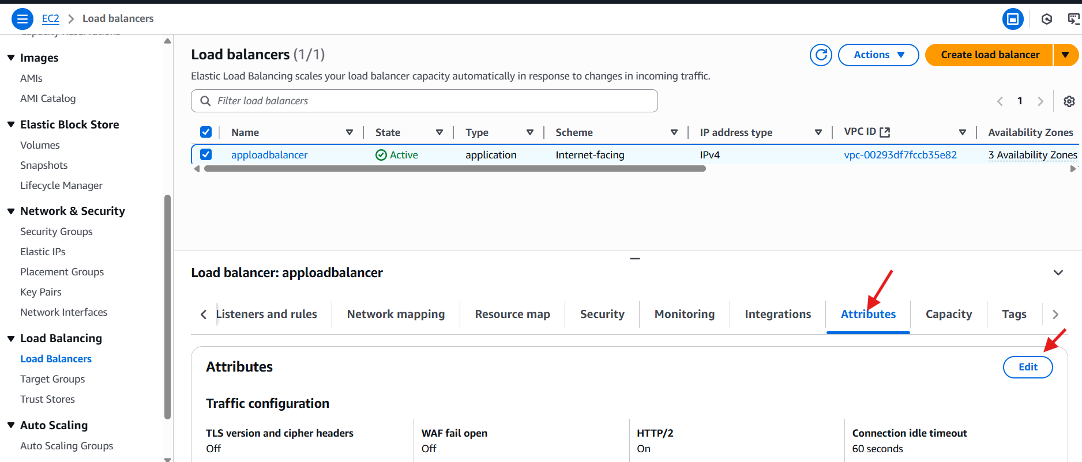
We can select the access logs and give the s3 url and click on save changes.
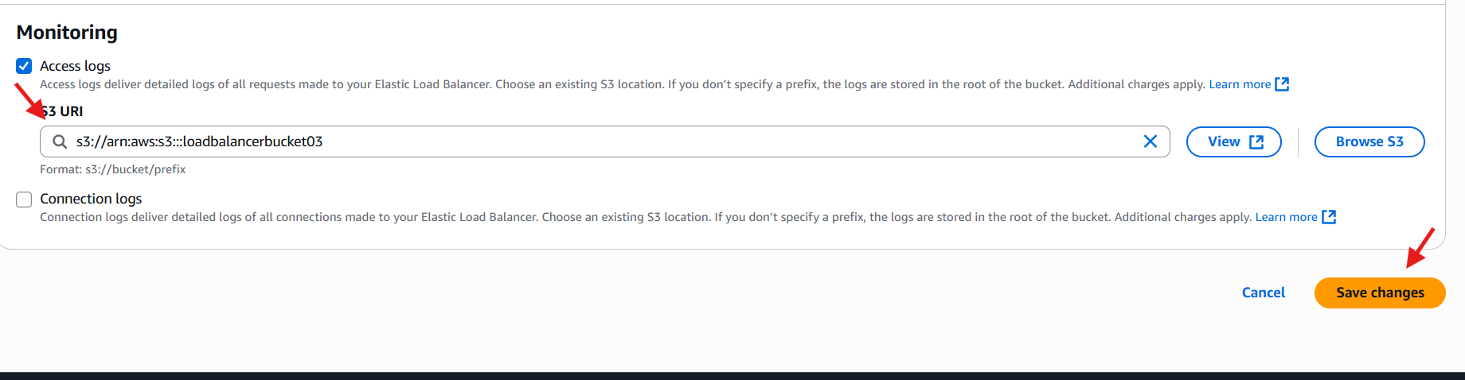
Here, the results we can see.
